Fault Trace Tool User Guide

Table of Contents

Introduction 3

Requirements 3

Overview 3

User Interface Elements 4

Version 4

Input Area 5

Fault Study 5

Lightning Study 6

Area Of Vulnerability (AOV) 9

Bookmark 11

Legend 12

Tools 12

Help 13

Background Selector 13

Scalebar 14

Coordinate Display 14

Zoom Control 14

Map Area 15

Structures 15

Lightning 16

Appendix – Example Case Study 19

Open Browser 19

Enter Time 19

Select Line 20

Select Station 20

Enter Distance 21

Double Ended Fault Location 22

Determine Autozoom 23

Structure Details 23

# Introduction

The Fault Trace Tool is a web-based tool for locating faults on a power system. This user manual provides a detailed description of the Fault Trace Tool’s features and how to get started using them.

# Requirements

Before using the Fault Trace Tool, you will need:

* Authorized account to access the tool
* Web browser (either MS Edge or Google Chrome)

# Overview

To start the tool, open a web browser and navigate to the following address: http://<<yourservername>>/openftt

Once the tool is opened, you will be presented with the following user interface:

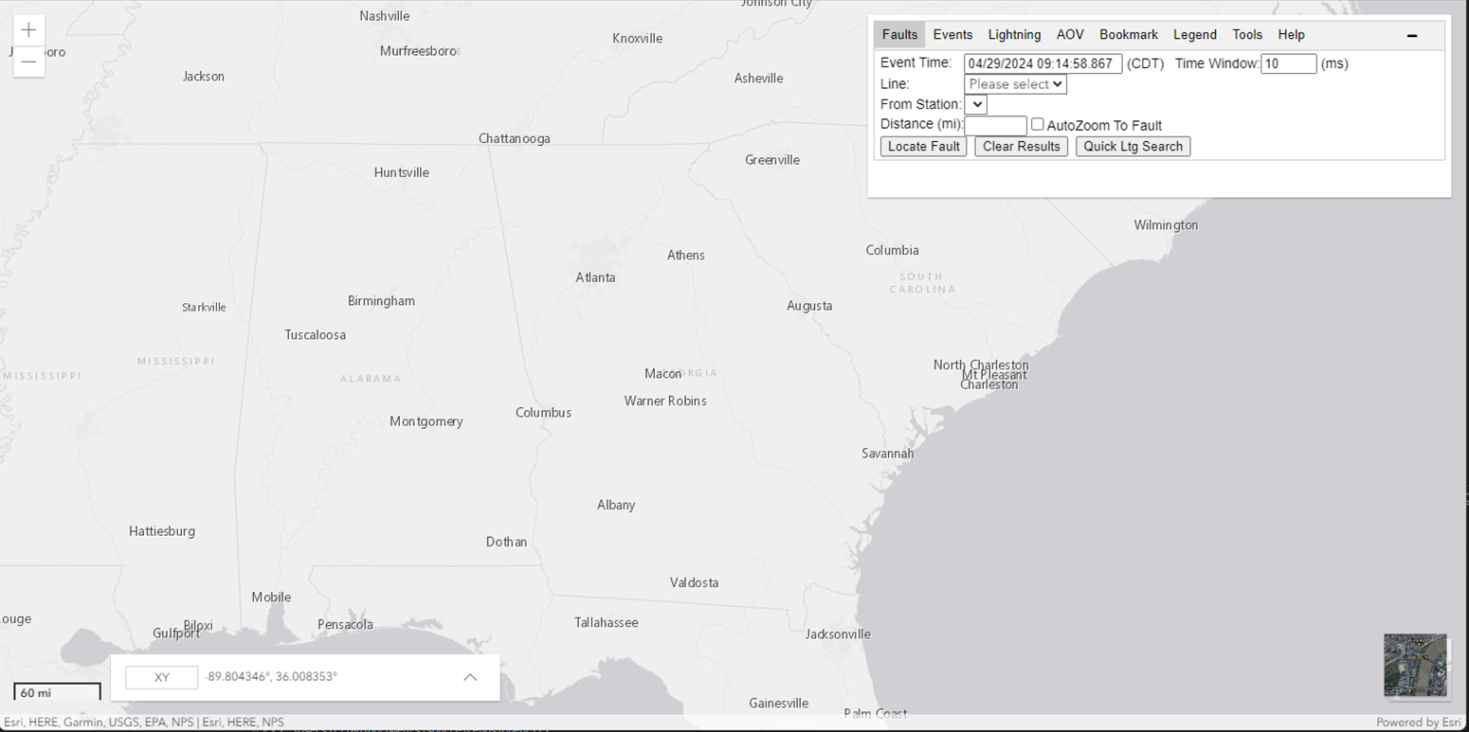

Figure 1 - Fault Trace Tool User Interface

# User Interface Elements

The user interface consists of six main regions: Version, Input Area, Background Selector, Scalebar, Zoom Control, and Map Area. Each of these regions is highlighted in the image below. Detailed descriptions of each region will be covered in subsequent sections.

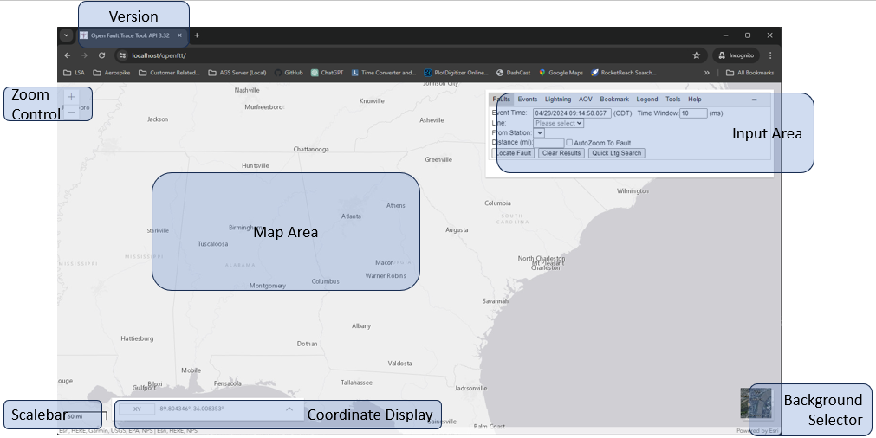

Figure 2 - Fault Trace Tool User Interface Regions

## Version

The version area of the map is located at the top and will help users identify which version of the Fault Trace Tool they are using. The version number will be updated once new features or bug fixes are deployed.



Figure 3 - Fault Trace Tool Version Display

## Input Area

The input area of the user interface is where the fault study and lightning study parameters are entered. The top of the input area has five tabs: Faults, Lightning, AOV, Bookmark, and Help. These tabs are used to enter parameters for a particular study type. The Bookmark tab will create a quick link to directly access (or email) the fault study parameters you have entered. The Help tab shows a link to the help document. The input area can be moved by clicking and dragging the window to a desired location on the screen. In addition, the [-] button in the upper right corner will minimize the Input area to an icon. Clicking on the [+] symbol, will make the Input area reappear.



Figure 4 - Fault Trace Tool Tabs

|  |
| --- |
| A close up of a sign  Description automatically generated  Figure 5 - Input Area Icon |

## Fault Study

The Faults tab helps locate the faults along the line selected. Optionally, a quick lightning search can be conducted around the line of interest at the time and window specified. Select the Faults tab to begin.

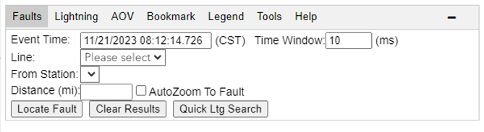

Figure 6 - Faults Tab

The workflow should follow this order:

1. Enter the Event Time. The time should be entered in the format MM/DD/YYYY HH:mm:SS.sss in Central Prevailing Time where:
   1. MM – Is a two-digit month (e.g., January is 01)
   2. DD – Is a two-digit day (e.g., The 1st of the month is 01)
   3. YYYY – Is a four-digit year (e.g., 2020 is 2020)
   4. HH – Is a two-digit hour (e.g., Midnight is 00, 1 PM is 13)
   5. mm – Is a two-digit minute (e.g., 5 minutes past the top of the hour is 05)
   6. SS – Is a two-digit second (e.g., 3 seconds past the top of the hour is 03)
   7. .sss – Is a three-digit subsecond (e.g., .640 is 640 ms past the top of the second)
2. Enter the Time window. The default is 10 ms, but may be changed to as many as 999 ms. The window will be the time before and after the Event Time when lightning is searched around the line.
3. Select a line from the drop-down list. This will:
   1. Show the line on the map.
   2. Populate the station drop-down list with stations near the selected line.
4. Select a station from the drop-down list to highlight the station on the map.
5. Type in the distance to the fault from the selected station.
6. To zoom into the fault automatically, leave “AutoZoom To Fault” checked. To manually zoom to the fault area, uncheck the “AutoZoom To Fault” option.
7. Click the Locate Fault button.
   1. An X will display at all locations that match the distance criteria.
   2. The map will zoom to the faulted structure(s) if the AutoZoom option is enabled.
   3. A list of the nearest structures will be displayed immediately under the input area.
8. For a double-ended fault location, repeat steps 2-5 above. New substation/fault pairs will receive new matching colors.
9. To clear the faults, click the Clear Results button.
10. Optionally, click the “Quick Ltg Search” button to locate lightning around the selected line. *Note: Clicking the “Clear Results” button also clears any lightning displayed.

## Events List

The Events tab shows events from OpenXDA for the time window provided. The system defaults to the last 24 hours. The tab can be set up as the default tab when OpenFTT opens. Finally, the system can be set to automatically refresh when an event time frame is provided.

However, a start time and stop time may be specified. Once the start/stop times are specified, clicking the Refresh button will populate a list of events. Clicking on the Open button will show the waveform that was recorded during the event. Clicking anywhere else on the row will show the event in the map display.

## Lightning Study

The Lightning Tab helps locate lightning around any arbitrary address or point. Click the Lightning tab to begin.

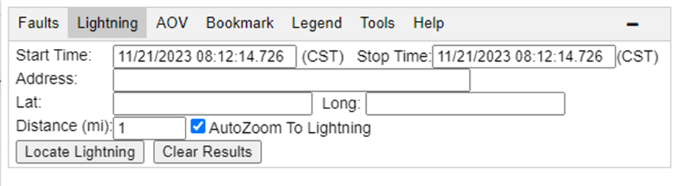

Figure 7 - Lightning Tab

The workflow should follow this order:

1. Enter the Start Time. The time should be entered in the format MM/DD/YYYY HH:mm:SS.sss in Central Prevailing Time where:
   1. MM – Is a two-digit month (e.g., January is 01)
   2. DD – Is a two-digit day (e.g., The 1st of the month is 01)
   3. YYYY – Is a four-digit year (e.g., 2020 is 2020)
   4. HH – Is a two-digit hour (e.g., Midnight is 00, 1 PM is 13)
   5. mm – Is a two-digit minute (e.g., 5 minutes past the top of the hour is 05)
   6. SS – Is a two-digit second (e.g., 3 seconds past the top of the hour is 03)
   7. .sss – Is a three-digit subsecond (e.g., .640 is 640 ms past the top of the second)
2. Enter the Stop Time window. The time should be entered in the same format as described in Step 1.
3. Type in the address or coordinates.
   * 1. For an address, type in a single row (i.e., 2100 E. Exchange Pl, Tucker, GA), then click the “Get Coords” button.
     2. For coordinates, type the latitude and longitude in the Lat/Lon fields.
4. Type in the distance to search from the coordinates/address specified.
5. To zoom into the fault automatically, leave “AutoZoom To Lightning” checked. To manually zoom to the fault area, uncheck the “AutoZoom To Lightning” option.
6. Click the Locate Lightning button.
   1. A Red X will display at the point of interest, and an orange circle will show the search area (specified by the Distance field).
   2. The map will zoom to the lightning study area if the AutoZoom option is enabled.
   3. A list of the lightning found will be displayed immediately under the input area.
7. To clear the lightning results, click the Clear Results button.

## Area Of Vulnerability (AOV)

The Area of Vulnerability tool allows a user to upload a file containing an AOV study. Click on the AOV Tab to activate the AOV Tool.

|  |
| --- |
| A screenshot of a computer  Description automatically generated  Figure 8 - AOV Tab |

To select a file from their local hard drive to upload click the Choose File button. Select a file from the file selection dialog box and click the Open button. The selected file will be drawn on the map as shown in the figure below.

|  |
| --- |
| A screenshot of a computer  Description automatically generated  Figure 9 - Example AOV Drawing |

The busses and lines will be drawn with a color that corresponds to the values in the table on the AOV Tab. By default, the values are in 10% increments from 0-100%. Clicking on an individual bus or line will show the value for that particular bus/line segment.

|  |
| --- |
| A screenshot of a computer  Description automatically generated  Figure 10 - Bus Popup Dialog |

The file format is a CSV where the first row contains the following headers: Bus1Name, Bus1X, Bus1Y, Bus1Val, Bus2Name, Bus2X, Bus2Y, Bus2Val, LineName. The first row should contain information about the reference bus for the study: the Bus1Name with the value of “REFERENCE BUS”, the longitude and latitude coordinates (using WGS84 coordinates) in the Bus1X and Bus1Y fields and a value of 1 in the Bus1Val field.

The remaining rows should contain the results of the AOV study. The image below shows an excerpt from a sample file:

|  |
| --- |
| A screenshot of a computer  Description automatically generated  Figure 11 - Example AOV Study File |

## Bookmark

The Bookmark tab reveals a text box with a hyperlink that can be copied to your browser, an email, or a document for quickly recalling the fault study. Click the Bookmark tab to access the hyperlink.

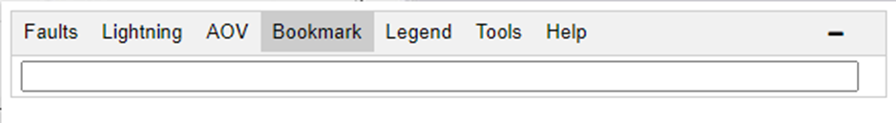

Figure 12 - Bookmark Tab

## Legend

The Legend Tab displays a legend of the symbology for the map. Click the Legend tab to access it.

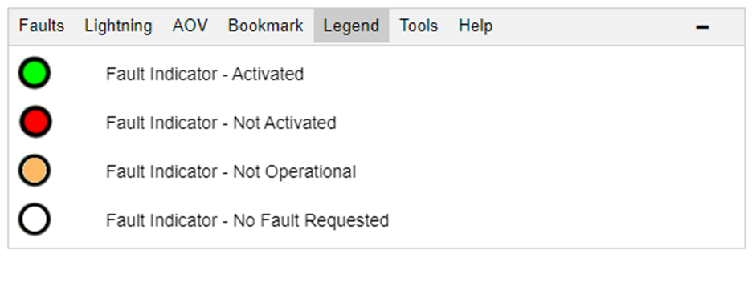

Figure 13 – Legend Tab

## Tools

The Tools tab reveals a button to open the Print Tool.

|  |
| --- |
|  |

Figure 14- Tools Tab

Clicking the Print Icon will expand the print tool options dialog.

|  |
| --- |
|  |

Figure 15 - Print Tool Dialog

## Help

The Help tab reveals a hyperlink to the help documentation. Click the Help tab to access it.

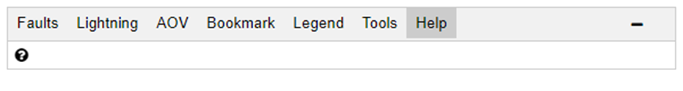

Figure 16 - Help Tab

## Background Selector

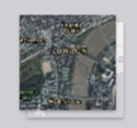

Figure 17 - Background Selector

The Background Selector in the bottom right corner enables the user to toggle between different map types. The default background is a light grey map. Click on the Background Selector to view the map background with satellite imagery. Subsequent clicks on the Background Selector will toggle the display between the available map types. *Figure 11* shows the same region with the two different map background options.

|  |  |
| --- | --- |
| Default View | Satellite View |

Figure 18 - Background View Comparison

## Scalebar

The Scalebar visually indicates the size and distance between features on the map. As you zoom in or out of the map display, the scalebar will change accordingly.



Figure 19 - Scalebar Display

## Coordinate Display

The coordinate display allows the user to select how coordinates are displayed as the mouse moves over the map area.

|  |
| --- |
| Figure 20 - Coordinate Display |

Clicking on the XY button will reveal a variety of other display formats including: Basemap, Decimal Degrees (DD), Degrees Decimal Minutes (DDM), Degrees Minutes Seconds (DMS), and others.

## Zoom Control

The zoom control is used to zoom in and out of the map areas. Clicking the + symbol will zoom into the map. Clicking the – symbol will zoom out of the map. The map will be centered on the current center of the map after zooming.

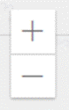

Figure 21 - Zoom Control

If your computer has a scroll mouse, this can be accomplished using the mouse’s scroll wheel. The act of pushing the scroll wheel up will zoom into the map. Pushing the scroll wheel down will zoom out of the map. The map will zoom with the center of the map being wherever the mouse is pointed.

If your computer is equipped with a trackpad, the zoom feature can also be activated using the scroll feature of your trackpad. On Macs, this is done with a pinch and zoom gesture. On Windows, this is usually performed by sliding fingers across the trackpad’s surface. Usually, scrolling up on the trackpad will result in zooming in, while scrolling down on the trackpad will result in zooming out. The map will zoom with the center of the map being wherever the mouse is pointed.

# 

# Map Area

The map area is where the results of the Fault Trace Tool are displayed.

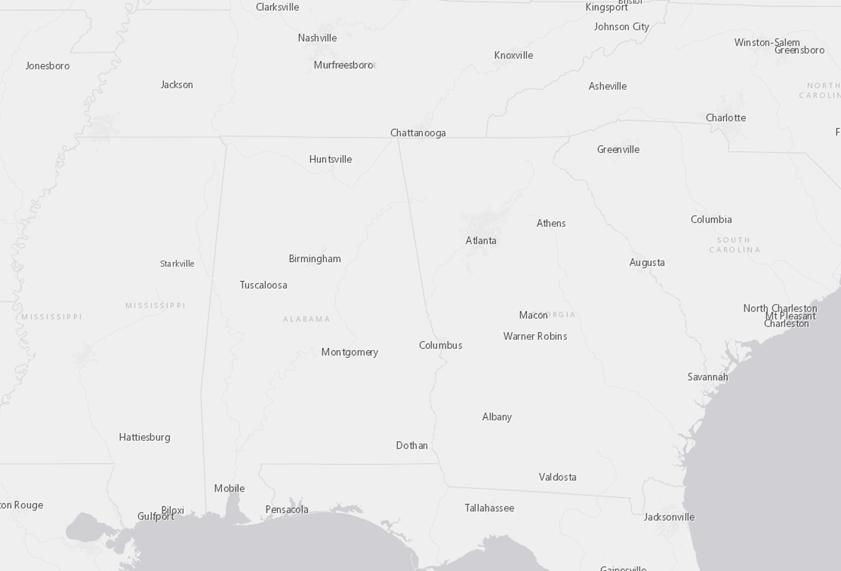

Figure 22 - Map Area

## Structures

When structures are displayed on the screen, as in *Figure 15*, click on a structure. A window will appear and display the distance of that structure to the end of the selected line. Distances are shown via the selected line and via a straight line. All distances will be displayed if there are multiple paths between a structure and a substation.

|  |  |
| --- | --- |
| Line with Structures   | Structure Distance Window   |

Figure 23 - Structure Distance Display

## Lightning

When lightning is displayed on the screen, as seen in *Figure 16*, the results of the lightning data are shown at the bottom of the input area.

Figure 24 - Lightning Results with Table

Click on a lightning event to show the details of that lightning strike. The 99% confidence ellipse is shown.

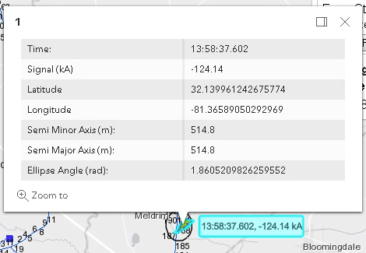

Figure 25 - Lightning Details Window

Fault Indicators

A black circle will appear when a fault indicator is present on the line. When the fault indicator status changes during an event, the circle’s color will be filled in green. If the fault indicator status does not change, the circle’s color will be red. If the fault indicator is not operational, the color will be orange.

|  |  |
| --- | --- |
| Fault Indicator With No Change | Fault Indicator With Change |

Figure 26 - Fault Indicators

Clicking on a fault indicator will reveal the data from the eDNA system. If the indicator has multiple phases being monitored, the data from each phase will be displayed. In the example below, the phases are denoted by P1, P2, and P3. In this case, the indicators did not change status.

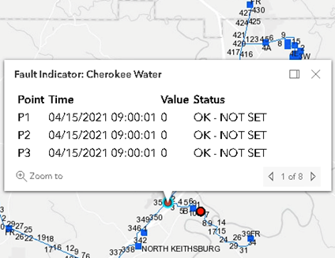

Figure 27 - Fault Indicator Details

# Appendix – Example Case Study

## Open Browser

Navigate to **Error! Hyperlink reference not valid.**openftt/

By default, the Faults tab is selected.

## Enter Time

Enter the Event Time and Time Window for the event. The Time Window will look at the specified number of milliseconds before and after the Event Time.

## Select Line

Select a line from the Line Drop Down List. The selected line will be displayed on the map.

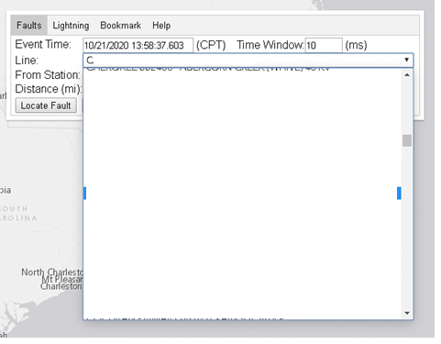

## Select Station

Select a station from the Station Drop Down List. The list has been pre-populated by stations along the line.

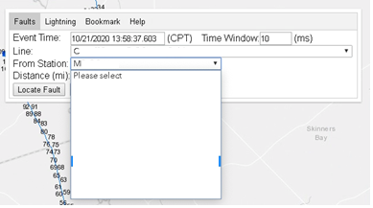

In this case, the C line was chosen. A purple marker appears on the M substation.

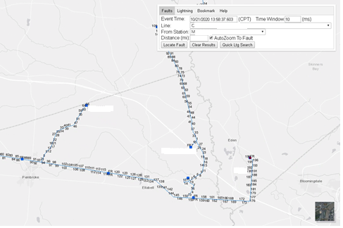

## Enter Distance

Enter the distance from the M station to locate the fault. An X is placed at the relevant location on the map, and listed in the table below the input area.

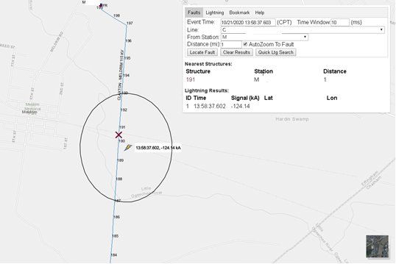

## Double Ended Fault Location

To run a fault study from a different endpoint of the line, select the other station. Enter the distance from that station. Click the Locate Fault button. The new station/fault will appear in a new color (in this case, red). Notice the table in the input area also shows the structure number in the corresponding fault color.

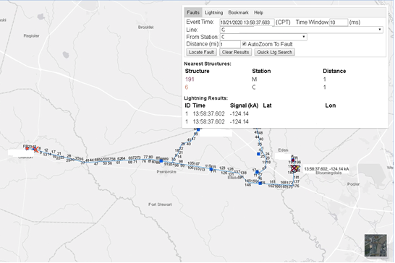

To clear the faults from the map, click the Clear Results button. Selecting a new line will also clear all of the faults and lightning from the map display.

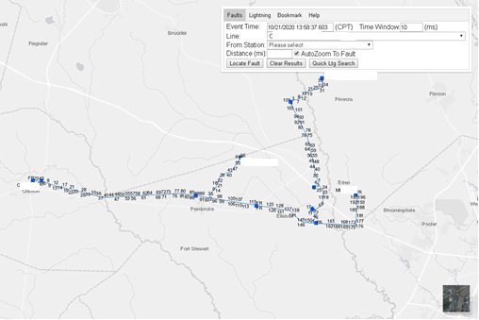

## Determine Autozoom

When AutoZoom To Fault is enabled, the system automatically zooms to the structure(s) where the fault has been located. If the feature is disabled, the map display will remain the same. Examples of both with the same fault parameters are shown below:

|  |  |
| --- | --- |
| AutoZoom To Fault Disabled | AutoZoom To Fault Enabled (Default) |

## Structure Details

When the structure is clicked on the map, a popup window appears. The window shows the structure’s distance to the stations near the line.

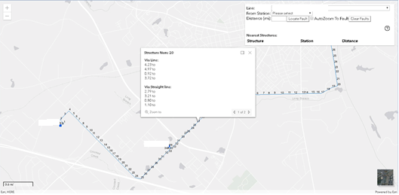

There are several components to the structure detail window. These areas are described below.

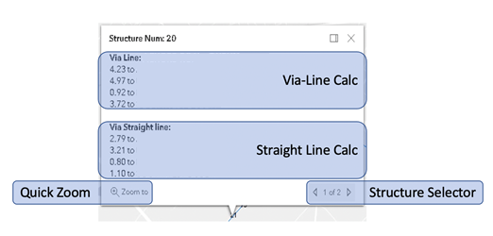

The Via-Line Calc is performed by computing the distance from the structure to the station by following the actual line back. If there are multiple paths, multiple distances will be reported.

The Straight Line Calc is performed by computing the shortest distance between each station and the selected structure. This does not follow the path of the line.

The Structure Selector appears when there are multiple structures close by. You can navigate between the structures by using the arrows to the left or right of the record counter.

The Quick Zoom button enables the zoom feature to zoom in to the structure currently being viewed.

The window can be closed by selecting the X in the upper righthand corner of the window.